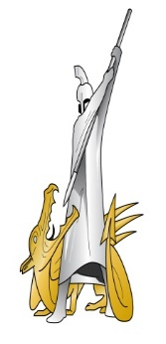
Ex TIGER TEMPLAR

Malta Battlefield Study
03-07 Oct 2022
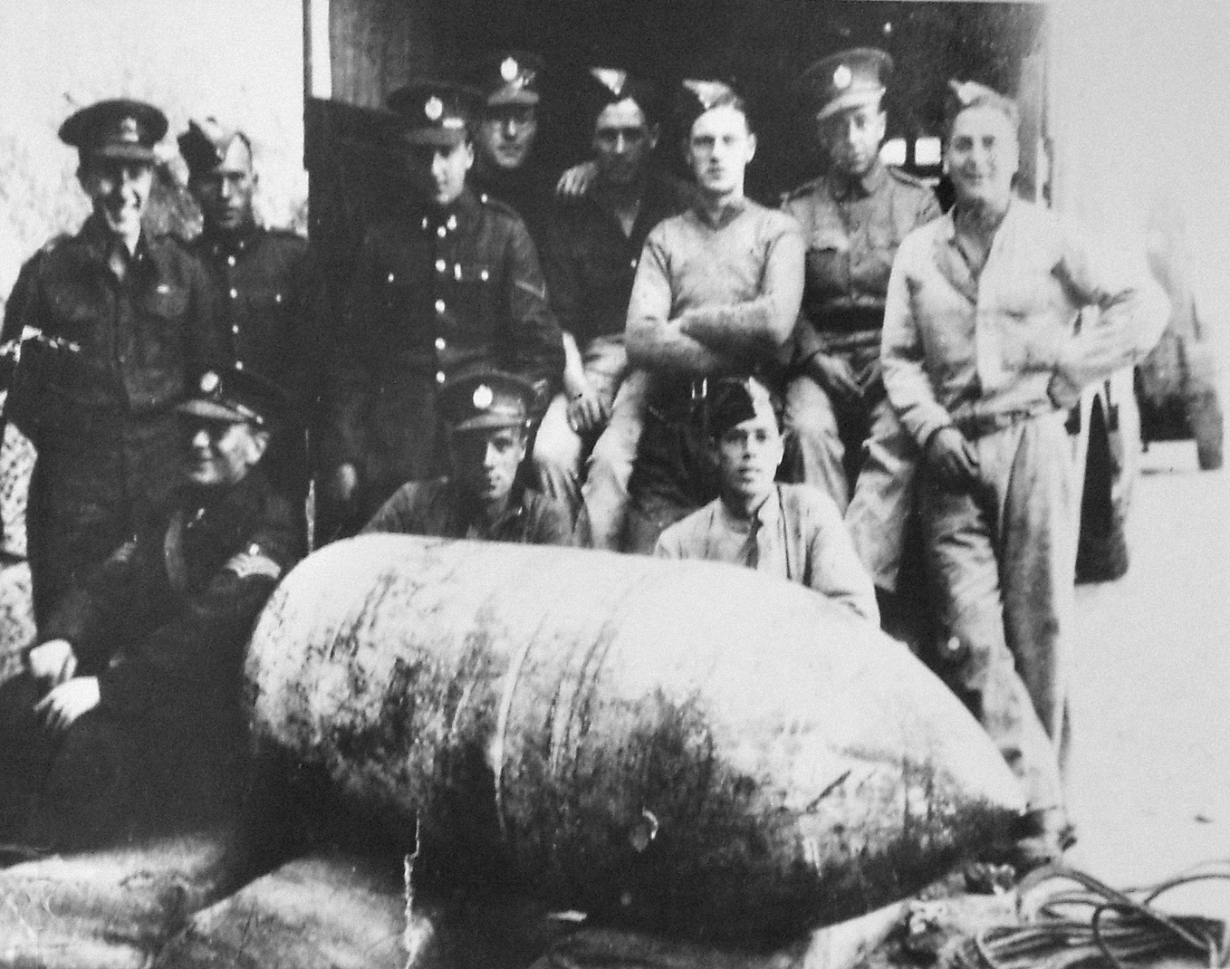

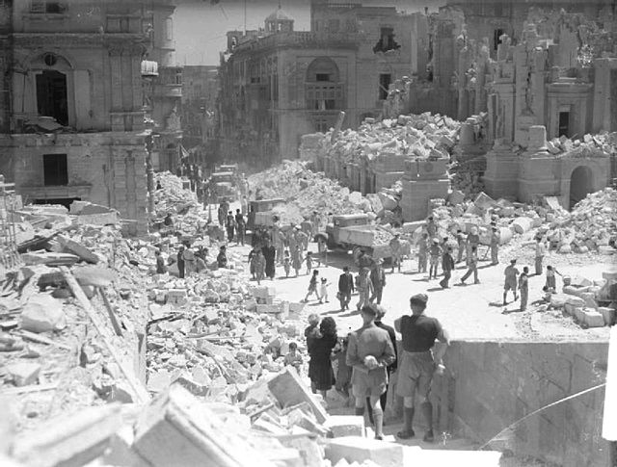

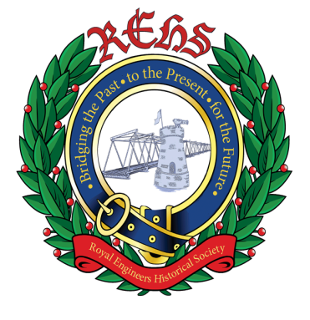

Conventional Munitions Disposal
Training Squadron.
Defence EOD, Munitions and Search
Training Regiment.

Capt PW Brazier RE
Ser | Date | Time | Event | Location | Remarks
01 | Mon 03 Oct | 0700-0800 | Breakfast | St Georges Bks | Lunch not provided for, claim back via JPA.
02 | Mon 03 Oct | 0930 | Briefing | ICP
03 | Mon 03 Oct | 1000 | Depart for Gatwick Airport | St Georges Bks
04 | Mon 03 Oct | 1900 | Arrive at hotel | Sliema, Malta
05 | Tue  04 Oct | 0700-0900 | Breakfast | Sliema, Malta | Collect packed lunches.
06 | Tue  04 Oct | 0930-1030 | Opera house study | Valletta, Malta | Group Task
07 | Tue  04 Oct | 1045-1200 | War Rooms | Valletta, Malta
08 | Tue  04 Oct | 1200-1230 | Saluting Battery | Valletta, Malta
09 | Tue  04 Oct | 1230-1330 | Lunch | Valletta, Malta
10 | Tue  04 Oct | 1400-1600 | National War Museum | Valletta, Malta | 1700: Transport pick-up Main Square, Valletta
11 | Tue  04 Oct | 1800-2100 | Evening meal | Sliema, Malta
12 | Wed 05 Oct | 0700-0830 | Breakfast | Sliema, Malta | Collect packed lunches.
13 | Wed 05 Oct | 1030-1200 | Harbour Tour | Sliema, Malta | 20 Euro personal contribution.
14 | Wed 05 Oct | 1200-1230 | Lunch | Rinella
15 | Wed 05 Oct | 1300-1400 | Fort Rinella | Rinella
16 | Wed 05 Oct | 1415-1430 | Kalkara Naval Cemetery | Kalkara, Malta
17 | Wed 05 Oct | 1500-1630 | Malta at War Museum | Vittoriosa, Malta | 1700: Transport pick-up @ museum
18 | Wed 05 Oct | 1800-2100 | Evening meal | Sliema, Malta
19 | Thur 06 Oct | 0700-0900 | Breakfast | Sliema, Malta | Collect packed lunches
20 | Thur 06 Oct | 1000-1200 | Mosta Dome | Mosta, Malta | 0930: Transport pick-up @ hotel
21 | Thur 06 Oct | 1200-1245 | Lunch | Mosta, Malta
22 | Thur 06 Oct | 1300-1330 | Pieta RE graves | Pieta, Malta | Transport pick-up 1300 @ Mosta Dome. Laying of wreath. Smart clothing required.
23 | Fri 07 Oct | 0700-0900 | Breakfast | Sliema, Malta | Collect packed lunches.
24 | Fri 07 Oct | 1100 | Check out | Sliema, Malta
25 | Fri 07 Oct | 1600 | Depart for Malta International Airport | Sliema, Malta | Transport: 1600 @ hotel.  Evening meal not provided for, claim back via JPA.
26 | Fri 07 Oct | 2100 | Arrive Gatwick Airport | London, UK

MALTA – A HISTORY OF CONFLICT
Malta measures 17.5 miles by 8.25 miles (1/4 the size of Greater London) with Gozo to the north and uninhabited islands of Comino and Filfa forms an archipelago. Despite being a popular tourist destination, Malta has a turbulent and violent past. Its location in the middle of the Mediterranean Sea has attracted civilisation and attack from a thousand years before the Great Pyramid at Giza was under construction.
5000BC civilised society in the Ghar Dalam caves.
3800BC Neolithic shrines and temples built on Malta.
218-208 BC Roman forces arrive in Malta, establish a capital at Melita (Mdina/Rabat on the modern island).
60BC St Paul shipwrecked on St Paul’s island and converted the island to Christianity.
870AD Arab invaders arrive from Sicily bringing agricultural techniques with them, as well as Islam.
1090-1127AD Norman raids on the islands.
1479AD Stability of governance following an alliance between Aragon and Castille.
1530AD Knights of the Order of St John land in the modern day Grand Harbour after being expelled from Rhodes in 1522.
March – September 1565AD - The First Great Siege. Knight Grand Master Jean Parisot de la Valette defends Malta against the Turks led by Ottoman Admiral Sinan.
9 June 1798 – 5 Sept 1800 AD French invasion. Maltese insurgency and Royal Naval blockade.
1814 Treaty of Paris. Britain given a controlling interest in Malta.
1914-1918 Malta used as a base to support operations in Gallipoli and Salonika.
1921 Malta granted self-government.
1940-1942 Third Siege of Malta.
1964 Malta granted independence.
1974 Malta became a republic
1979 British forces withdraw
1993 Malta joined the EU
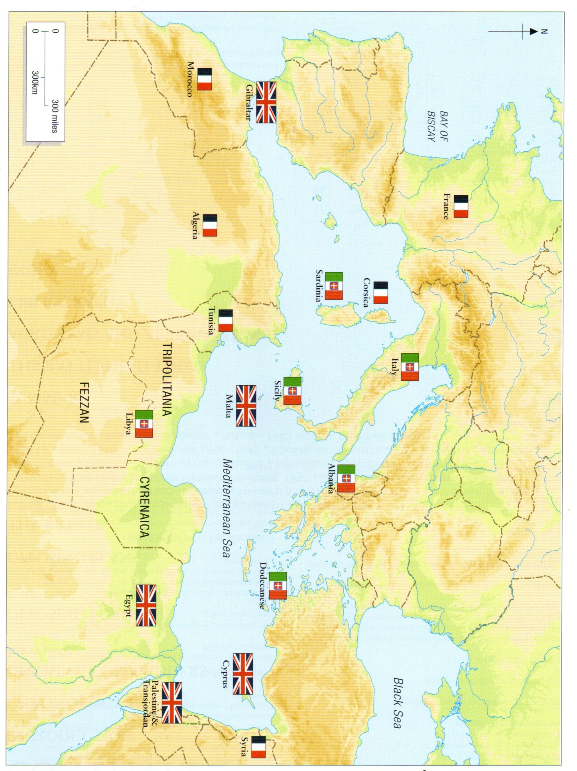
The Mediterranean in 1940
CHRONOLOGY OF THE THIRD SIEGE OF MALTA
1940 | 1941 | 1942
 | 10 Jan First Luftwaffe ops in central Mediterranean  MW 5½ & EXCESS arrive (3 supply ships)  16-19 Jan ‘Illustrious Blitz’ | 19 Jan MW8A & MW8B arrive (3 supply ships)
 | 21 Feb Cheshire and Hampshire Regts arrive (MC8)
 | 23 Mar MW6 arrives (4 supply ships) | 7 Mar Op SPOTTER – First Spitfires arrive  23 Mar MW10 arrives (2 supply ships)
 | 6 Apr German invades Yugoslavia | 15 Apr Malta awarded the George Cross  29-30 Apr Hitler sanctions Italo-German invasion of Malta (op HERCULES)
 | 9 May MW 7A & MW 7B arrive (5 supply ships, 2 tankers)  Luftwaffe forces redeployed to Eastern Front  20 May German forces invade Crete | Luftwaffe units redeployed from Sicily.  10 May HMS Welshman arrives  18 May Schnellboot mining ops suspended
10 Jun Italy declares war on UK and France  11 Jun Regia Aeronautica begins operations against Malta  21-22 Jun First Hurricanes reach Malta | 6-30 Jun  Ops ROCKET, TRACER, RAILWAY I & II reinforce Malta’s fighter units. | 10 Jun GM4 arrives (2 supply ships). MW11 fails  21 Jun Tobruk falls to Axis forces.  22 Jun Hitler cancels op HERCULES
24 Jul GM1 arrives (6 supply ships)
25-26 Jul Attack by MAS X on Grand Harbour
12 Aug Op HURRY – First RN operation to ferry aircraft via carriers |  | 15 Aug SS Ohio arrives (op PEDESTAL)
2 Sep MF2 convoy arrives (3 supply ships) | 28 Sep GM2 arrives (8 supply ships)
11 Oct MF 3 convoy arrives (4 supply ships)  28 Oct Italy invades Greece |  | 11-18 Oct last major air attacks
9 Nov MW 3 convoy arrives (5 supply ships)  17 Nov Op WHITE (Hurricane delivery – 5 out 13 arrive)  26 Nov MW 4 convoy arrives (4 supply ships)  28 Nov Op COLLAR (2 supply ships) |  | 3-5 Nov Last Schnellboot mining ops.  11 Nov HMS Manxman arrives with dried milk and concentrated food  20 Nov MW13 arrives (4 supply ships Op STONEHENGE)
20 Dec MW 5 A/B convoys arrive (7 supply ships) | II Fliegerkorps ordered to Sicily  16/17 Dec Schnellboots commence mining operations off Malta

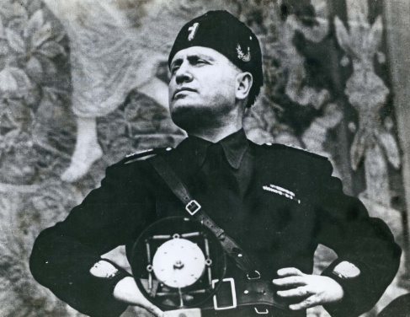
In the early 20th century, North Africa and much of the Middle East had been claimed by various European powers. Italy dominated Libya, Somalia, Eritrea and the Ethiopian Empire. France occupied most of north-western Africa: Tunisia, Algeria, French Morocco and French West Africa, as well as Cameroon to the south. Britain controlled territory from Sierra Leone on Africa’s West coast, the Gold Coast and Nigeria and east to Sudan, Egypt, Palestine and beyond. Italy’s entry into the war posed a threat, not only to Malta, but also in the Middle East, jeopardising oils supplies and access to and from India and the Far East via the Suez Canal.

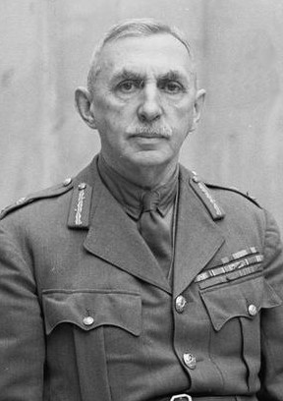
Malta was bombed within hours of Benito Mussolini’s Italy declaring war on the UK and France on 10 Jun 1940. The RAF bombed Turin and Genoa that night. In North Africa, British troops entered Libya from Egypt and started the Desert War – lasting for three years and with which Malta would be inextricably linked.

OPPOSING COMMANDERS
ALLIED
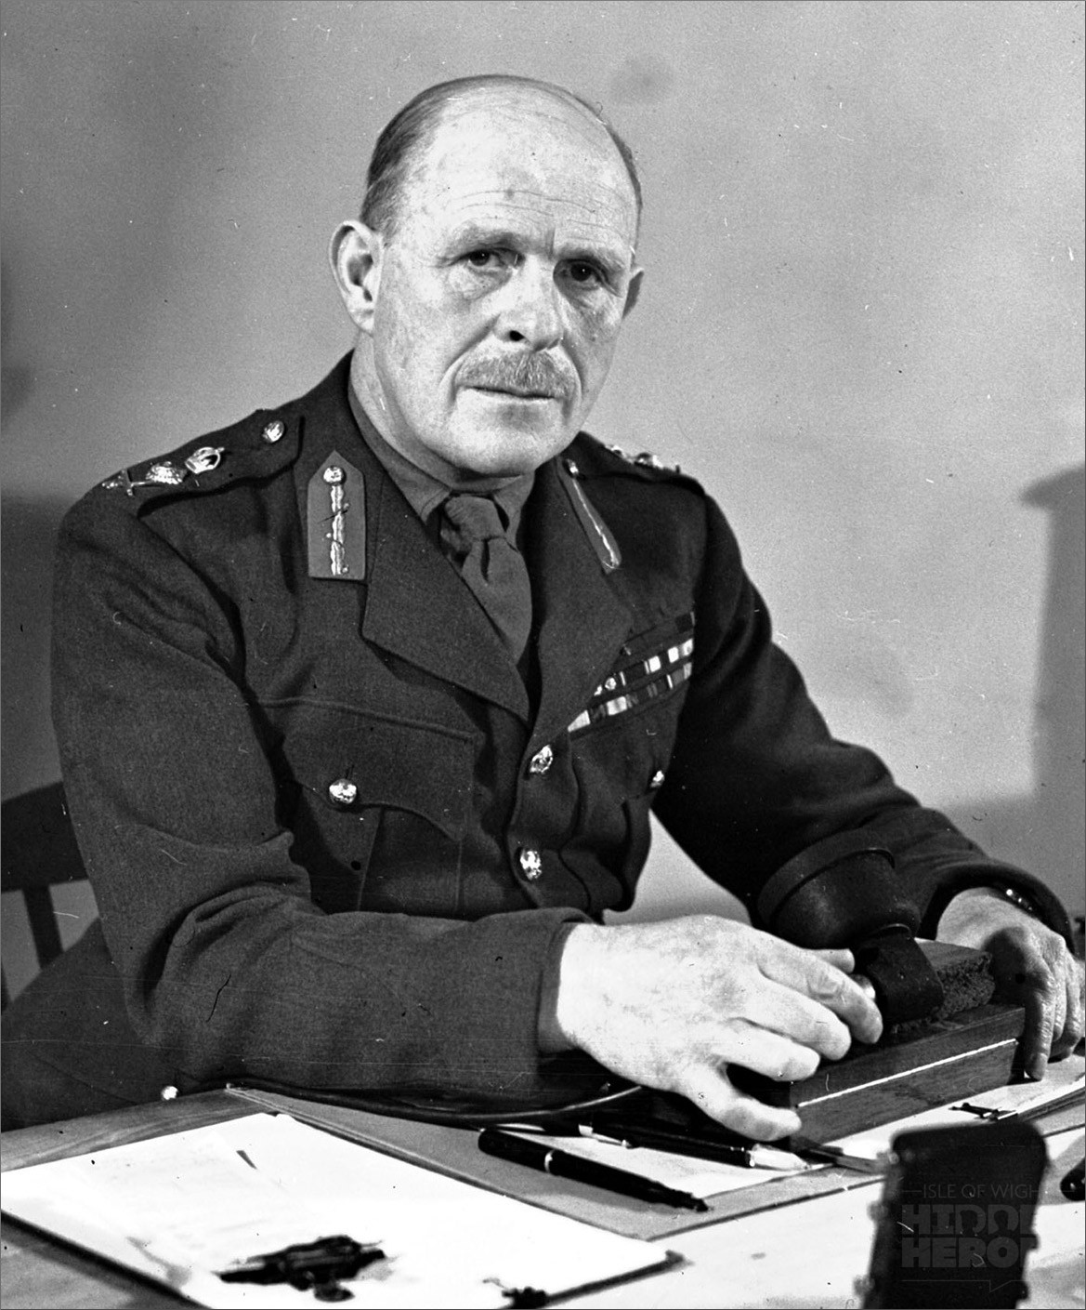
In May 1940 Lt-Gen William GS Dobbie took over as Governor and C-in-C of Malta from the ailing General Sir Charles Bonham-Carter. Dobbie had joined the RE in 1899 and seen action in the Boer War and First World War. He was supposed to retire in August 1939, but had his service extended. He was replaced in May 1942 by Lord Gort VC, who had commanded the BEF during the Dunkirk evacuation in 1940.

Vice Admiral WTR Ford was Vice Admiral-in-Charge, Malta from 1937. He was replaced in Jan 1942 by Vice Admiral Sir Ralph Leatham
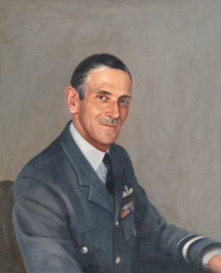
Along with the maritime campaign, the air battle was key to Malta’s survival. Air Officer Commanding (AOC) RAF Mediterranean in 1939 was Air Commodore FHM Maynard. He was replaced in Feb 1941 by Air Vice-Marshal HP Lloyd, who had been an RE dispatch rider during the First World War before joining the Royal Flying Corps. Lloyd, in turn, was replaced in July 1942 by New Zealander Air Vice-Marshal Keith Park. Park has served at Gallipoli and on the Western Front before commissioning into the RFC. He was AOC 11 Group RAF Fighter Command (which included RAF Debden, now Carver Barracks Wimbish) during the Battle of Britain before being sidelined into a training role before Malta. Park left Malta in Jan 1944.

AXIS
Italian
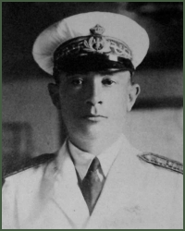
Generale GT Lalli served during the First World War in the Army and then the Corpo Aeronautico Militaire, which later became the Regia Aeronautica, the Italian Royal Air Force. He was in charge of operations from Sicily against Malta from June 1940 until Jan 1941.
From Top: Benito Mussolini, Lt-Gen Dobbie, Lord Gort, AVM Park, Generale Lalli.
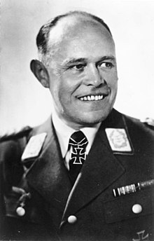
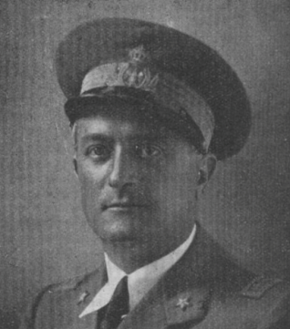
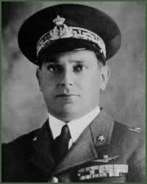
He was replaced by Generale R Mazzucco, a fighter pilot from the First World War, who handed over command to Silvio Scaroni, Italy’s second highest ace from the First World War, who led operations from Sicily until December 1943.
Clockwise: Generale Mazzucco, Generale Scaroni,
Generalfeldmarshall Kesselring
GERMAN
GeneralFeldMarshall Albert Kesselring fought as an artillery officer on the Eastern and Western Fronts during the First World War. He was instrumental in the development of the Wehrmacht between the wars and became Chief of Staff of the Luftwaffe in 1937. During the Battle of Britain and the early stages of Op Barbarossa, he commanded Luftlotte 2n and became responsible for air operations in the Mediterranean in Nov 1941.

OPPOSING PLANS
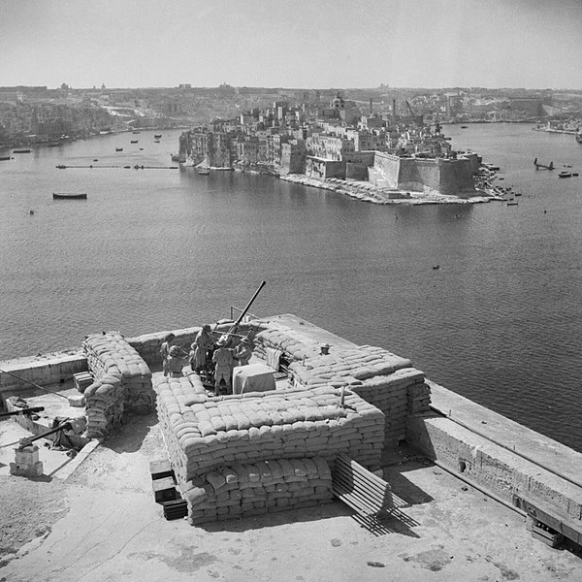
In June 1940, the Regia Aeronautica was considered to be a modern, well-equipped branch of Italy’s military. When Il Duce declared war, Malta became a primary objective with fighter and bomber operations launched from Sicily. Towards the end of 1940, elements of the Luftwaffe’s X.Fliegerkorps began to arrive in Sicily and took on most of the operations over Malta. The invasion of the USSR saw Luftwaffe units deployed east in mid-1941, but II Fliegerkorps was deployed to Malta before the start of 1942.
Above: 40mm Bofors gun overlooking Grand Harbour

The struggle between air attacks, re-supply convoys and delivery of RAF fighters to Malta is summarised in the table on page 4.
The initial air defence was by four biplane Sea Gladiators which were constructed from storage and flown by hastily-trained RAF pilots. They became the ‘Faith, Hope and Charity’ defenders of Malta mythology, especially as it was rare to see all four in the air. Supported by AAA sited around the island – see map on p.8.
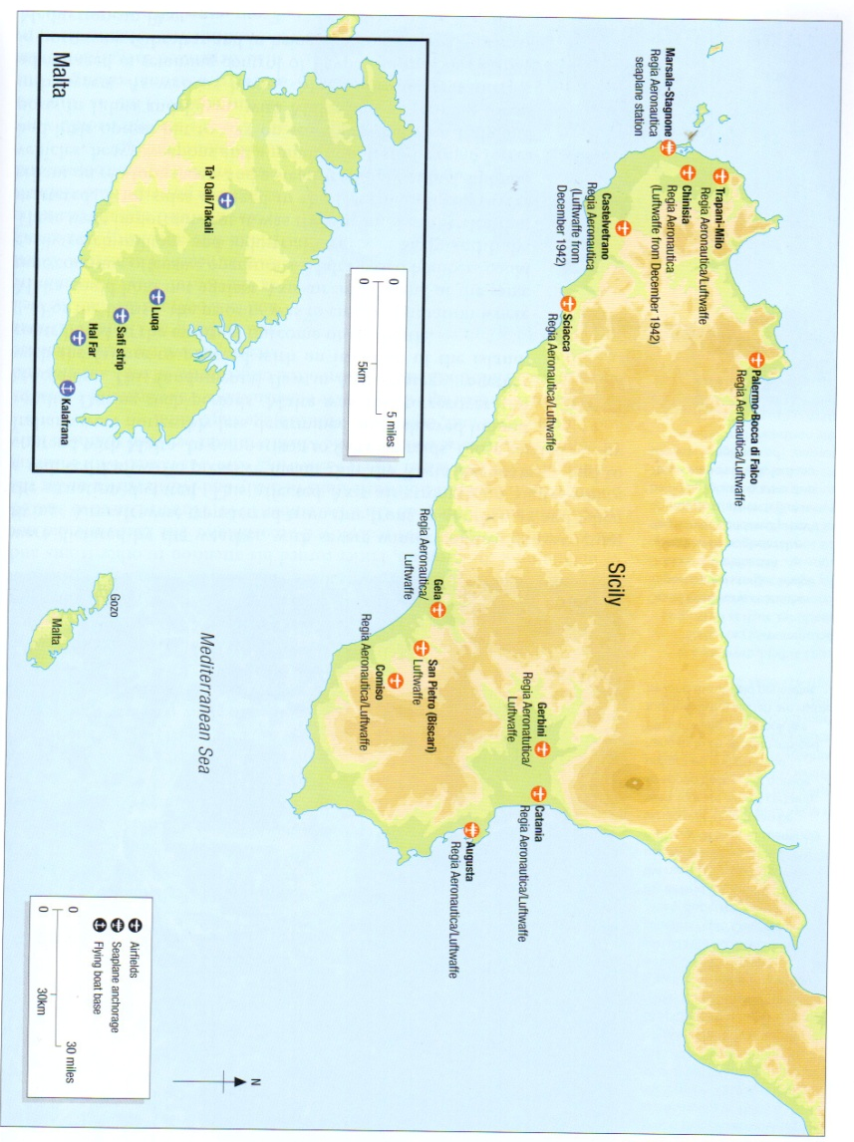
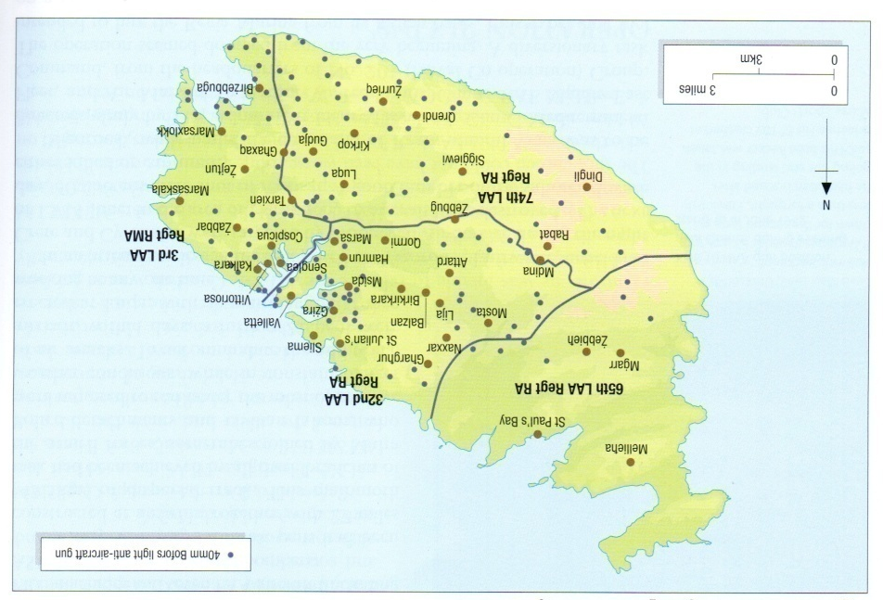
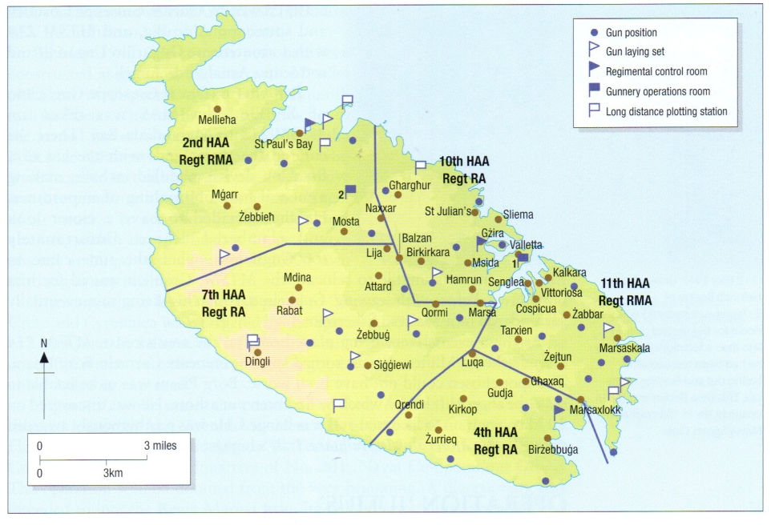
Top: Allied and Axis Airfields
Middle: Heavy AAA positions on Malta in 1942.
Bottom: Light AAA positions on Malta In 1942.
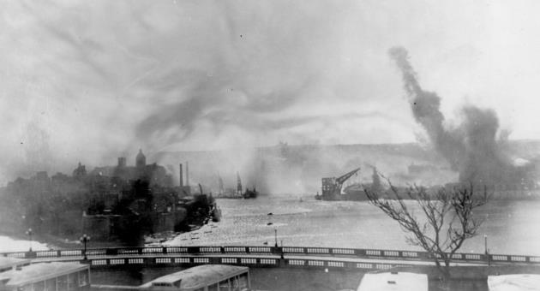
Malta was kept supplied through a series of complex naval operations, undertaken by merchant ships and escorting warships of the Mediterranean Fleet from Alexandria and Force H from Gibraltar. Unloaded vessels were also escorted out of Malta. Submarines operated from Malta to patrol between Sicily and Malta and RAF light bombers operated from Malta to tack enemy airfields in Libya.
Above: HMS Illustrious (centre, right of cranes) under attack at Parlatorio Wharf.

The aircraft carrier Illustrious was badly damaged by JU87 dive bombers during convoys MF 5½ and ‘Excess’ and had to put into Parlatorio Wharf in Grand Harbour, Valetta for repairs on 11 Jan 1941. This required a massive effort to make the ship sea-worthy before further damage could be inflicted. The Illustrious Blitz of 16-19 Jan 1941 saw large air attacks, heavy damage to the harbour, as well as to HMS Illustrious and other ships moored in the harbour – 300 lives were lost at sea on the convoys, 60 (mostly civilian) casualties on the ground and several aircraft and crew on both sides.
On 25 Jul 1941, Italian naval forces attacked the Grand Harbour in motor torpedo boats (MAS) and a sloop Diana carrying nine, one-man torpedo boats (MT) and a two-man motor torpedo boat (MTS). Diana also towed a motor boat (MTL) carrying pair of two-man ‘human torpedoes’ (SLC), with detachable explosive bows. The force was detected by radar and approached the island with its defences on Full Alert. The attacking force was engaged by shore defences and the RAF and destroyed.
By April 1942, day and night raids were routine. Raids were fewer, but heavier with the dockyards, and airfields being the main targets. On 7 Apr, 272 aircraft attacked the Grand Harbour and all three airfield in what Luftwaffe records put as the ‘heaviest attack so far’. Of a total of 400 tons of high-explosive bombs, 280 tons fell on Valetta. HMS Penelope, under repair in dry dock, was holed so many times by bomb fragments that she was remembered as HMS ‘Pepperpot’. HM King George VI awarded the George Cross to Malta on 15 Apr, the only time that such an honour had been granted to a community. Later that month, Op CALENDAR saw the launch of two squadrons of Spitfires from USS Wasp, with 46 arriving safely. In May, HMS Eagle and USS Wasp repeated the task, 60 out of 64 reached Malta. Shell rationing was halted to provide increased AAA cover during the operation.
Supply operations also continued, with HMS Welshman arriving on 10 May. The unloading process was screened by seven tons of smoke in 92 generators positioned around No. 5 dock, 100-200m from the ship. In conjunction with AAA and fighter cover, the smoke proved an effective means to unload ships at speed.
Convoy MW11 arrived with 2 supply ships in Jun 1942, but for the loss of six warships, one MTB, five merchant ships and 17 Allied aircraft. This led to improvements in unloading and dispersal of stores, as well as turning around aircraft and defending/repairing the runways and hardstandings.
Op PEDESTAL
Axis air attacks lessened in Jul 1942 as the fighting around El Alamein drew Luftwaffe forces to Africa. Air Vice Marshal Park arrived at this time and changed the air defence policy to ‘Forward Interception’ where raids were engaged before reaching Malta. However the food situation on Malta was dire and the next supply convoy had to succeed to prevent mass starvation.
Op PEDESTAL (Convoy WS 21S) assembled at Scapa Flow and left the Clyde on 2/3 Aug, leaving Gibraltar on 09/10 Aug. At the Skerki Channel, part of the convoy (Force X) would continue to Malta, whilst the remainder (Force Z) returned to Gibraltar.
Aircraft Carriers: Furious, Victorious, Argus, Eagle, Indomitable
Battleships: Nelson, Rodney
Cruisers: Cairo, Nigeria, Kenya, Manchester, Phoebe, Sirius, Charybdis
Destroyers: 30.

Transports: Empire Hope, Dorset, Wairangi, Rochester Castle, Waimarama, Brisbane Star, Port Chalmers, Almeria Lykes, Santa Elisa, Clan Ferguson, Glenorchy, Melbourne Star, Deucalion.
Tanker: Ohio

11 Aug: Furious despatched 38 Spitfires to Malta. HMS Eagle sunk.
12 Aug: Air attacks. Destroyer Foresight damaged and sunk, Deucalion damaged and abandoned. Indomitable damaged and unable to launch aircraft. Nigeria, Ohio, Kenya hit by torpedoes; Cairo and Clan Ferguson sunk.
13 Aug: HMS Manchester damaged and scuttled; Glenorchy and Wairangi sunk; Almeria Lykes damaged, Santa Elisa damaged and later sunk.
Rochester Castle, Melbourne Star and Port Chalmers arrive in Grand Harbour in the evening
14 Aug: Waimarama destroyed with heavy loss of life; Ohio and Dorset immobilised, Dorset later lost.
Penn, Ledbury and Bramham escorted the Ohio. Brisbane Star arrives in Grand Harbour
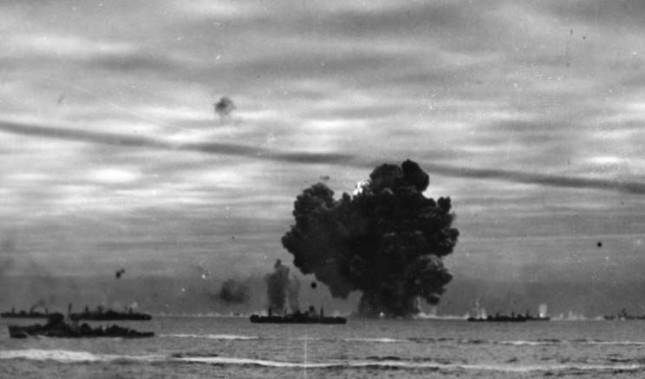
15 Aug: Ohio (lashed to HMS Penn and HMS Ledbury) arrived in Grand Harbour. 3,000 army personnel supported Maltese stevedores to unload cargo, 23,000 tons dispersed into dumps. This was sufficient to sustain the island for the remainder of the siege.

Left: Destruction of unknown supply ship during Op PEDESTAL.
Below Left: Troops unload supplies.
Below Right: Queues for a milk ration.

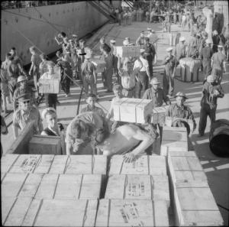
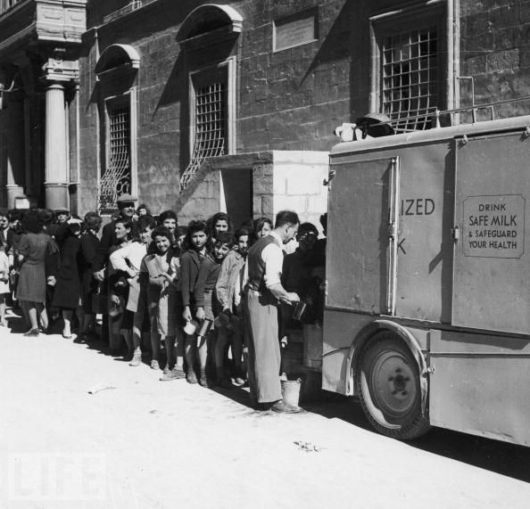
From autumn 1942, offensive air operations by the Allies increased, along with submarine attacks against Axis convoys to North Africa. The supply situation for General Rommel and the Afrika Korps was made worse by the Allied offensive at El Alamein on 23 Oct and then the Op TORCH landings in French North Africa on 08 Nov. Malta was saved and then became the launch point for Op HUSKY, the invasion of Sicily in 1943.

SUMMARY
If Malta had fallen in 1942, the situation in North Africa would have probably deteriorated to such an extent that the Suez canal would have been captured by the Afrika Korps. The Middle East oil supplies and links to the Far East would have been lost, with consequences for the US fight against Japan in the Pacific. Holding Malta was vital to the Allies’ success. As part of defending Malta, RE Bomb Disposal was vital to maintaining military effectiveness. Similarly, it was vital to maintaining civilian morale, as explained in the next section.

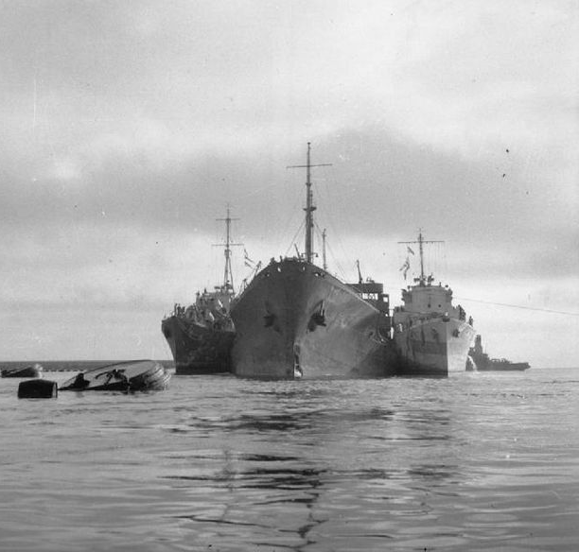

Above: SS Ohio enters grand Harbour lashed to RN destroyers HMS Penn (left) and HMS Ledbury (right).

MALTA BOMB DISPOSAL
The first Italian air raid on Malta was around 0630hrs on 11 Jun 1940, followed quickly by six more that day. The first UXB was in Rudolph Street, Gzira, which was evacuated. The next morning, Sprs Walter, McDonald and Scott were sent from 24 Fortress Coy RE at Lintornof Bks to meet Lt Eastman RAOC on site. They worked from 1130hrs to 1930hrs that day and 0730hrs 1515hrs on 12 Jun to recover a 250lb HE bomb which had severed a sewer pipe. Three slabs of gun cotton were detonated on the bomb, rendering it safe.
In May 1940, the RAOC had been given the responsibility for all UXO outside of Admiralty and RAF premises. Lt Eastman and Capt Jephson Jones were assisted by a team from 24 Fortress Coy RE, all volunteers:
L/Sgt Charles Parker, Cpl Cecil Brewer, Sprs William Scott, Duncan Mc Donald and Robert Walter.
This team tackled 275 unexploded bombs and shells in five months. Both officers were awarded the George Cross.
At the end of Aug 40, ahead of the Blitz on London the War Office determined that the RN would carry out Bomb Disposal on all ships, below the high water mark, on harbours, docks and other Admiralty property and make safe all parachute mines, wherever they fell. The RAF had responsibility for bomb disposal on Air Ministry property, including airfields; the Army covered the rest and could be called upon by the other two.
The first RE officer sent to Malta was Lt Ellis Talbot, who had experience of BD in Wales. He arrived in Nov 40. Wales had eight BD officers, with a section each; Lt Talbot was in charge of all Army BD on Malta and Gozo with a section of 20 sappers from 24 Fortress Coy and he had to prioritise all tasks, instead of being tasked by HQ.
Each section had the following trades: carpenter/joiner, driver, mechanic, electrician, fitter, mason and timberman, plus a number of GD sappers (‘pioneers’) and a cook, As an overseas section, all tradesmen had to be trained to clear small incendiary and AP bombs, as well as Allied shells. NCOs could defuse UXBs up to 50kg with standard fuzes. The officer had to take on ‘Priority’ UXBs, all HE bombs over 50kg and any smaller bombs with complex/challenging fuzes.
Above: Jan 1941: BD section with the 1000kg+ bomb from the ‘Illustrious Blitz’.

During the ‘Illustrious Blitz’ in Jan 1941, Valetta plus the ‘Three Cities’ of Senglea (now Isla), Vittoriosa (now Birgu) and Cospicua (now Bormla) were badly hit. 200 homes were destroyed and over 500 damaged. All but the most essential BD tasks (16 UXBs recorded on 19 Jan alone) were paused and all available RE personnel were called to Senglea and Vittoriosa to assist Army and civilian teams to rescue survivors.
L/Sgt Parker and No. 1 BD Section tackled a bomb under a collapsed nunnery, which required several days of clearing masonry by hand to reach a 1000kg+ Armour Piercing bomb (a ‘Fritz’ or ‘Esau’) intended for HMS Illustrious. By means of block and tackle rigged from steel girders between damaged buildings the section removed the bomb to the top of a flight of steps (possibly 18 Steeple Street, Cospicua) and then to rural San Pietru where Lt Talbot could remove the fuze, although it was officially recorded as having been ‘demolished’. For this L/Sgt Parker received a GM and Lt Talbot, Sprs Leonard, Miller and Mc Carthy were specially commended.
An incident in Balbi Street, Marsa near the docks after the Illustrious Blitz made clear the need for further RE BD personnel on Malta. A UXB (an Italian 43lb Thermite incendiary) was found by an ARP warden and a police constable evacuated the street and Lt Talbot arrived, guided to the device by a boy scout the next day. Although quickly defused, the delay in Lt Talbot’s arrival caused the local authorities to complain to the Lieutenant Governor and request that ARP/police should be trained to recognise UXBs and decide upon the need to evacuate an area.
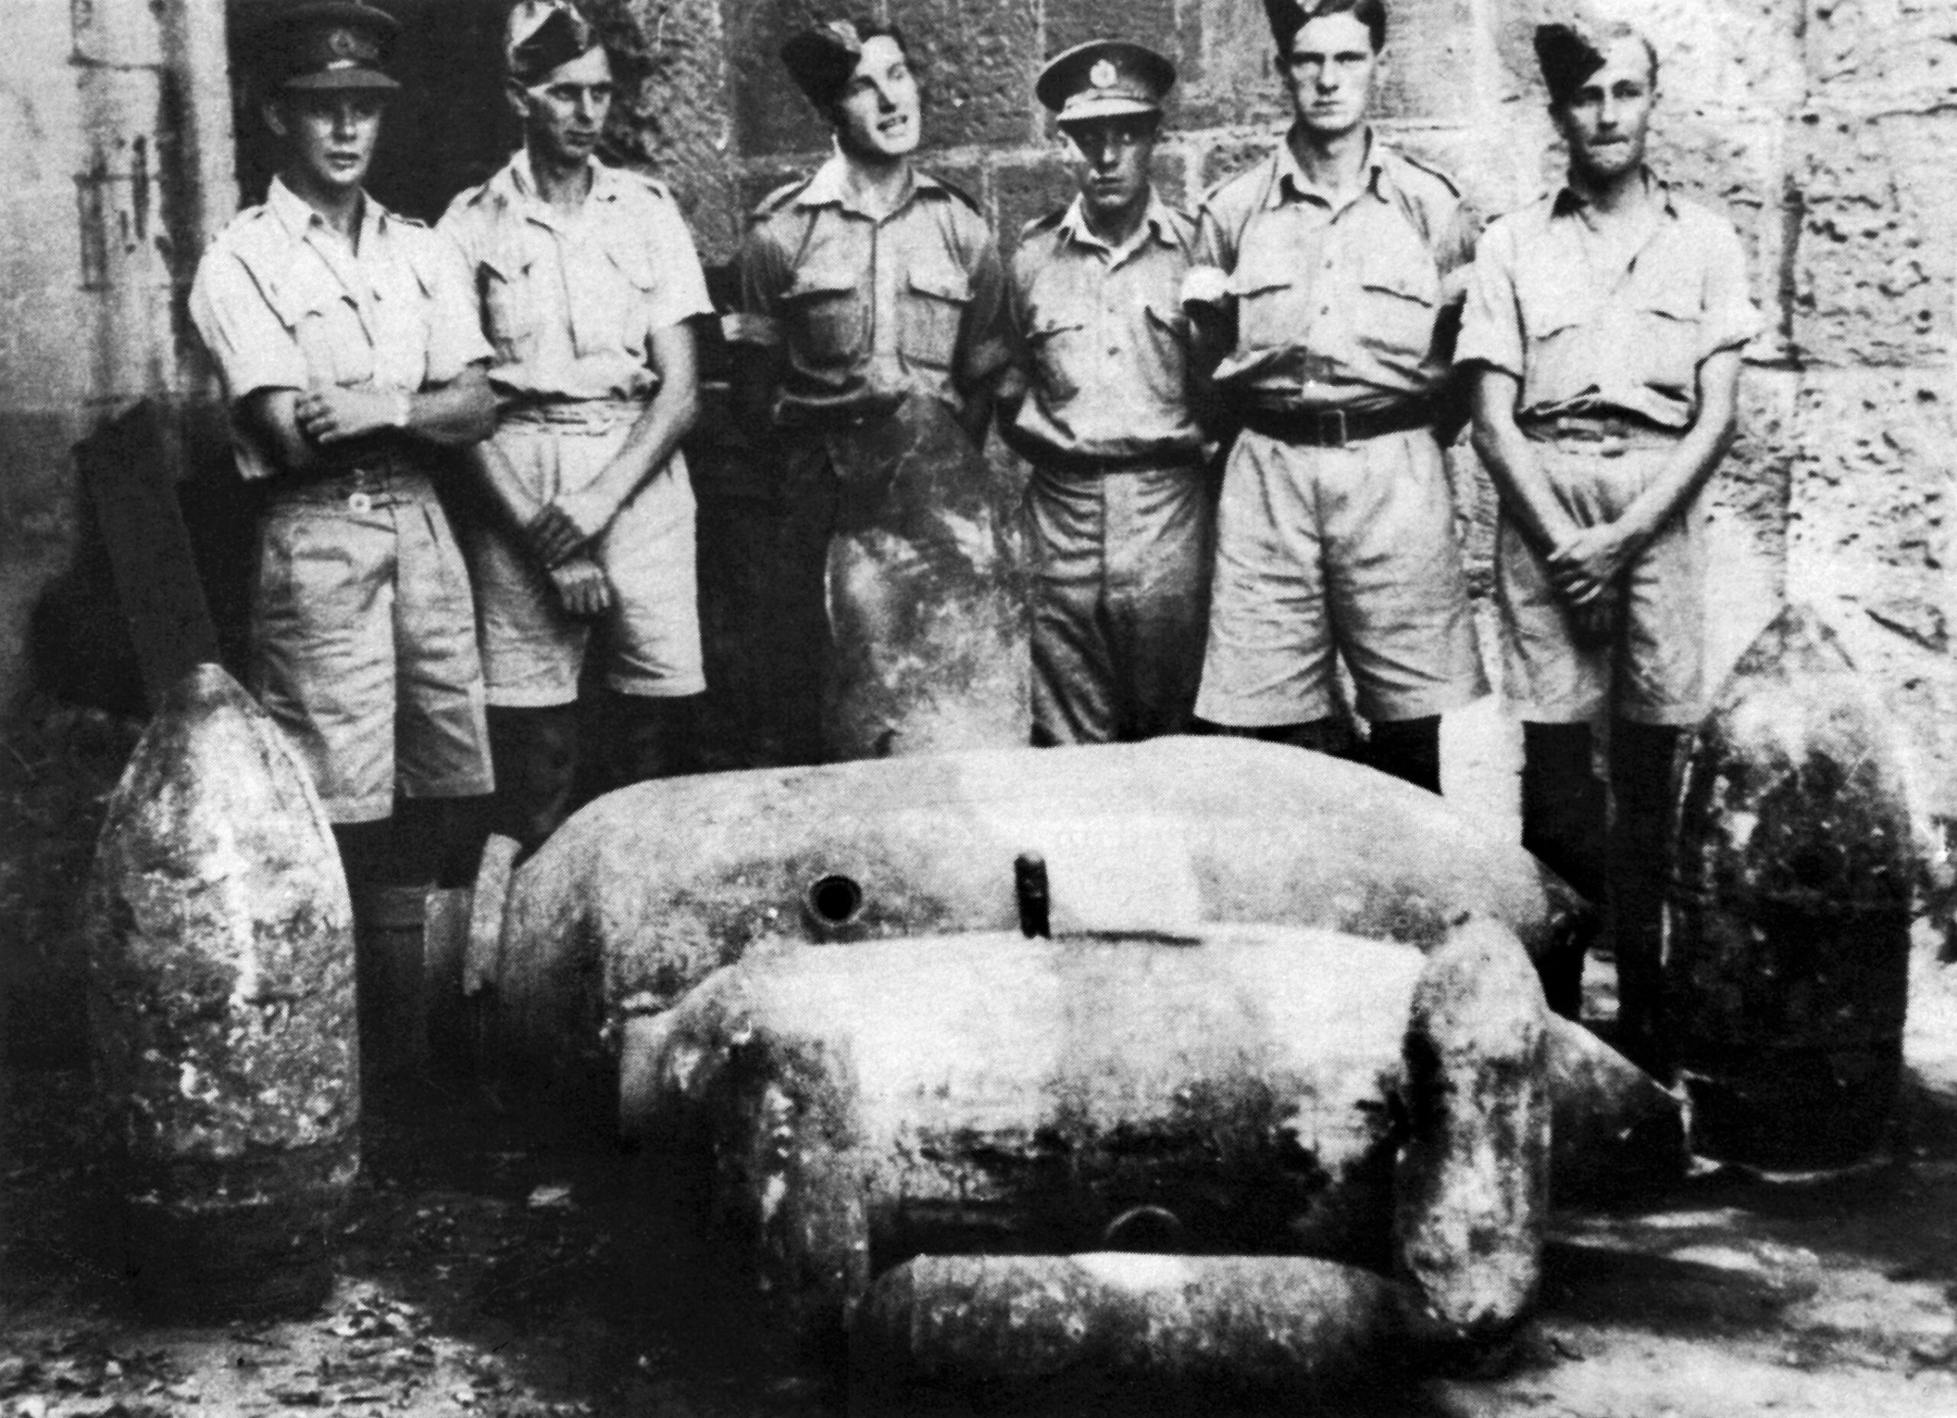
Italian fuzes were all mechanical and relatively straightforward to tackle. German Rhienmetall electrical fuzes were harder: impact or short delay, delayed-action (long delay, Type 17) and anti-handling. One in every seven German UXBs contained the Type 17 fuze of up to 80 hours delay.
Left: Summer 1941, l to r: Lt Carroll, (unkown), Spr L Miller, Spr H Turner, Spr D McCarthy, (unknown).
.

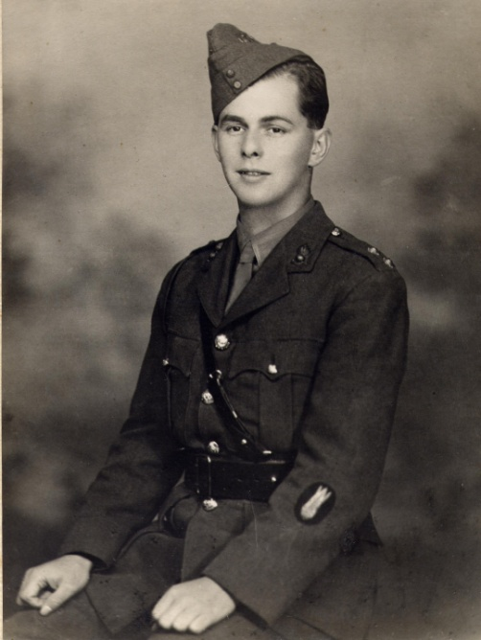
On 5 Mar 1941 100 Luftwaffe aircraft attacked the airfield at Hal Far and put it out of action. The sole RAF Warrant Officer could not cover the BD work required. Lt Talbot tackled 19 UXBs, all close to the runways, while the sappers dug for the remaining 11. In several cases the bombs were carted away from the runway still fuzed. 1 x 500kgAP, 10 x 500kg SAP, 2 x 200kg GP and 7x 50kg GP bombs were defused and pushed over the nearby cliffs into the sea. Six more HE bombs were disposed of in the following days, for which the RAF rewarded the sappers with a sack of potatoes.
In four months to the end of April 1941, No. 1 BD Section has responded to 96 UXB reports, totalling 10 tons of bombs (40 HE devices, 9 incendiaries) and 10 AAA shells.
As well as the awards to Lt Talbot and L/Sgt Parker, Cpl Brewer and Spr Scott received the BEM for their work.
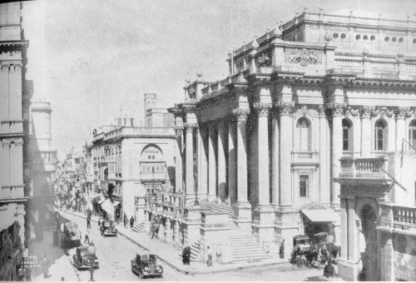
Lt Talbot handed over to Lt Carroll and Sgt Holland in Apr 1941 and a second BD Section was established, making No. 127 and No. 128 BD Sections. Lt Blackwell arrived in December 1941. Lt Carroll was the BD officer responsible for dealing with the thermos bombs at the Opera house, which will be covered during the study.

Top: Lt GD Carroll RE
Bottom: Opera House on Kingsway (now Republic Street).
.

Unfortunately, Lt Carroll was struck by peritonitis and hospitalised, in Apr 1942 – much worse than the ‘Malta Dog’ (dysentery) which affected most service personnel on the island at some time. About this time, the Luftwaffe began putting the No. 17 clockwork time-day fuze on bombs as small as 50kg. This development was briefed to the sections and the need to correctly identify fuzes prior to removal was emphasised, Any unmarked fuzes had to be referred to Lt Blackwell before the bomb was tackled.
The loss of Lt Carroll meant that more work had to be taken on by the NCOs. LSgt Parker and Cpl Brewer were therefore authorised to work on bombs with impact fuzes up to 250kg. They could also inspect reported UXBs and refer them to Lt Blackwell as necessary, everything else had to be dealt with by the Lt. Lt Blackwell instructed the NCOs in removal of fuzes by remote control. However the sections were very short of equipment: only one ‘clockstopper’ and two electric stethoscopes. The priority demand went from Malta Governor and C-in-C Lt-Gen Dobbie directly to the War Office and a ‘clockstopper’ was flown out. Later that month Lt Ashall arrived to replace Lt Carroll.
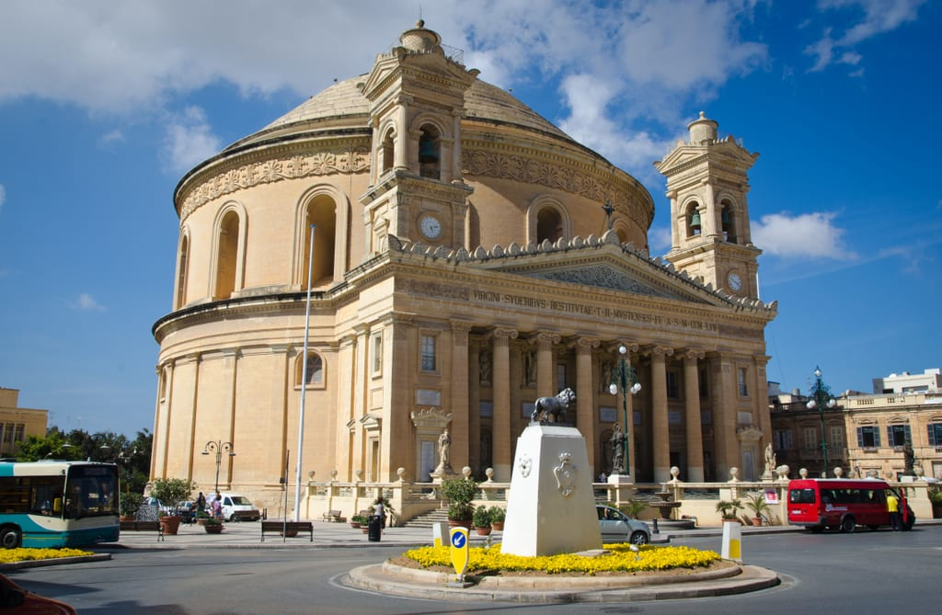
Between 01 and 11 Apr 1942 Lts Blackwell and Carroll made safe 60 large HE bombs. Prior to the arrival of Lt Ashall, the NCOs defused 60 more.
Right: Mosta Rotunda

09 Apr saw the UXB task at Mosta Rotunda, which will be covered during the study.
Although successful tasks like that at Mosta were important for local morale, the food situation wea dire, both for locals and the military. By May 1942, the typical daily ration for the BD teams was:
12oz (340g) bread; 1oz (28g0 margarine; ½ oz (14g) jam/marmalade and 1oz (28) each of tea, tinned milk and sugar. A typical lunch meal was ¾ oz (21g) tinned bacon and 1oz (28g) tinned cheese; dinner was 6oz (170g) preserved meat, 1oz (28g) onions, 8oz (227g potatoes and fresh vegetables, plus 2oz (57g) tinned fruit.
Despite heavy Luftwaffe attacks against the airfields and further taskings there, the RAF force grew and received Spitfires to replace Hurricanes. Although air attacks often took up ten of the average thirteen hours of daylight, massed daytime bombing was brought to a halt.
6 Jun 1942 brought the first use of SD2 ‘Butterfly’ bombs against Malta, when hundreds were dropped on a line from the airfield of Luqa, the town of Haz-Zebbug, Ta’Qali and out to the north-west coast, matching the emergency of the dropping of Thermos bombs in Nov 1941. Within two days, butterfly bombs were reported across the island, leading to a general warning. In the next week, the two sections dealt with 350 of the devices and over 1,000 by the end of the month. The arrival of Convoy GM 4, meant that troops were diverted to unloading tasks and one of the BD sections was placed on standby to dealt with devices hindering the that process.
Afterwards, techniques were developed to remove the ‘Butterfly’ bombs. The arming process involved unwinding the arms before the device hit the ground. If less than five threads were visible, it could be picked up and moved into a pile for disposal (saving on explosives).
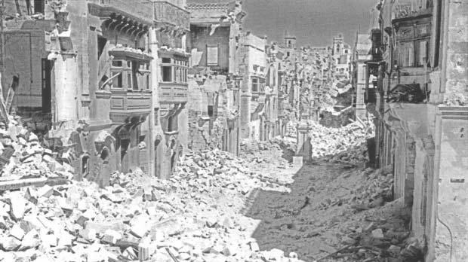

Above: Victory Street, Senglea

At the end of July, Lt Blackwell and PC Baylis removed an unexploded 250kg bomb, containing two ticking clockwork fuzes from St Rocco Street in Birkirkara. In August, the BD sections sent volunteers to be part of the force of 2,000 personnel working to repair the airfields. The lack of air attacks meant that the number of UXBs remaining to deal with fell to nine.
When the US tanker Ohio was towed into Grand Harbour on the Feast Day of the Assumption – Santa Marija – BD work was suspended so that 3,000 personnel could assist with unloading stores from the Op PEDESTAL convoy. Another 1,500 personnel assisted on the airfields to service and refuel the aircraft to protect the arrived ships which enabled 32,000 tons of supplies to be unloaded and dispersed. UXB reports dwindled to less than 12 a day and sometimes none. Higher-altitude attacks left bombs embedded deeper into the ground, requiring fourteen, 14’ deep shafts to be dug into the stony ground.
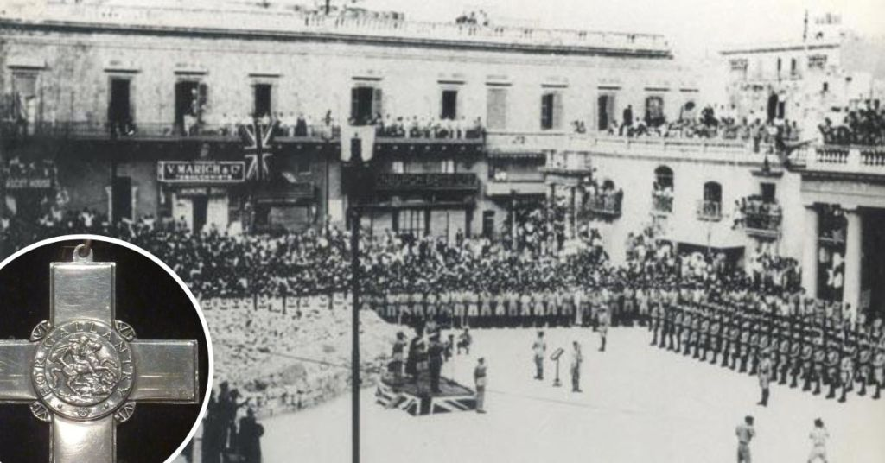
Above: Presentation of the George Cross to Malta, 13 Sep 1942.
.

By 11 Sep 1942, only four HE UXBs remained to be dealt with. The George Medal was officially presented to the island by the Governor, on behalf of the King on Sunday 13 Sep. The November convoys averted starvation on the island, but the last ‘sting’ was the use of anti-handling fuzes on butterfly bombs dropped on the island (132/150 had these fuzes).
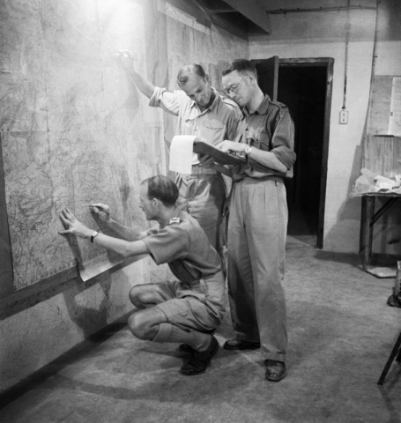
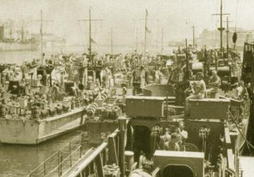
In December 1941 there had been 169 air raid alerts, by December 1942 it was down to 35, but the year had seen 12,300 tons of bombs dropped on the island. The siege was lifted and the island went onto the offensive and became the HQ for Op HUSKY, the invasion of Sicily in 1943.

Left: Planning Op HUSKY in underground HQ on Malta.
Right: Landing craft for Op HUSKY in Grand Harbour.

FUZES AND BD EQUIPMENT
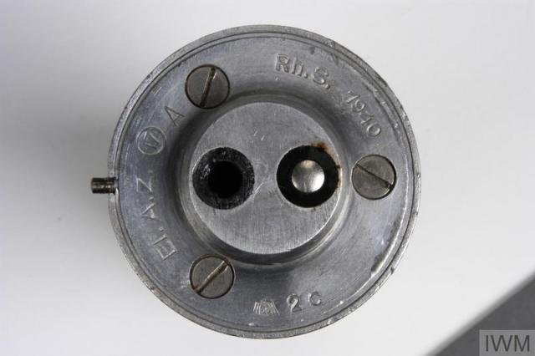
Left: Type 17 Fuze

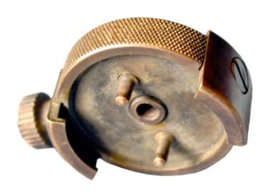

Above: Crabtree Discharger

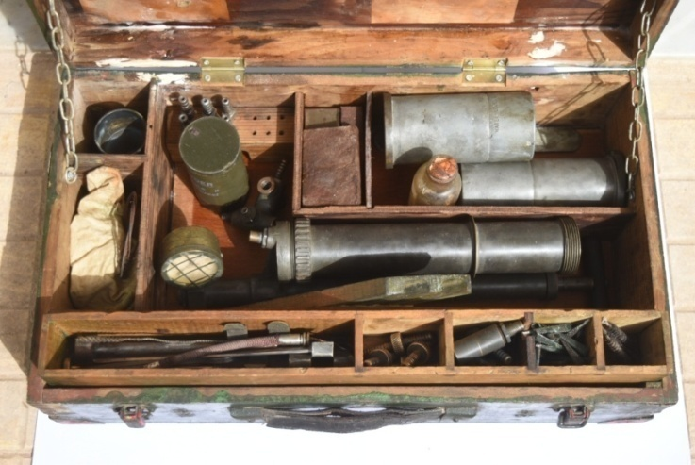
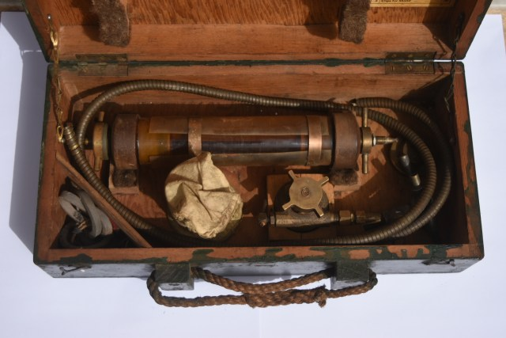
Above: Stevens Stopper in its transport case

Above: BD Plug Fuze discharger set

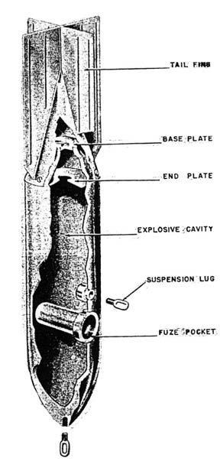

Left: German 50kg (Amatol) GP/SC bomb.
1.1m x 0.2m (inc. Fins). Total weight 55kg

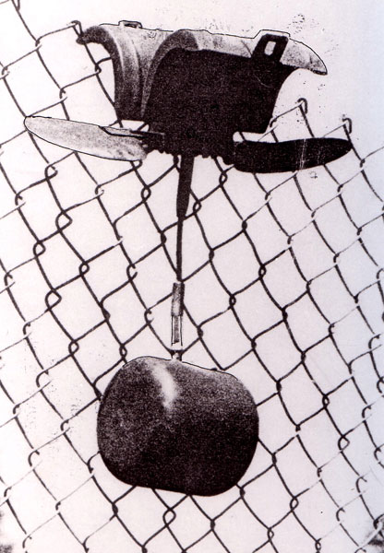

Left: SD2 ‘Butterfly’ bomb

Below: ITALIAN ‘Thermos’ bomb

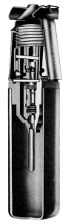
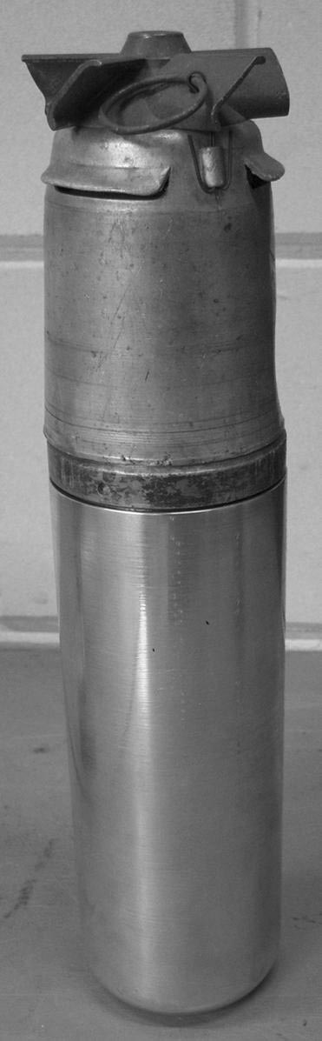
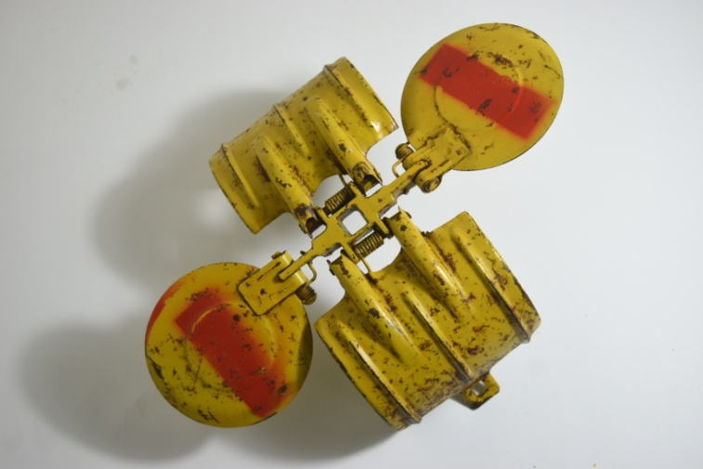

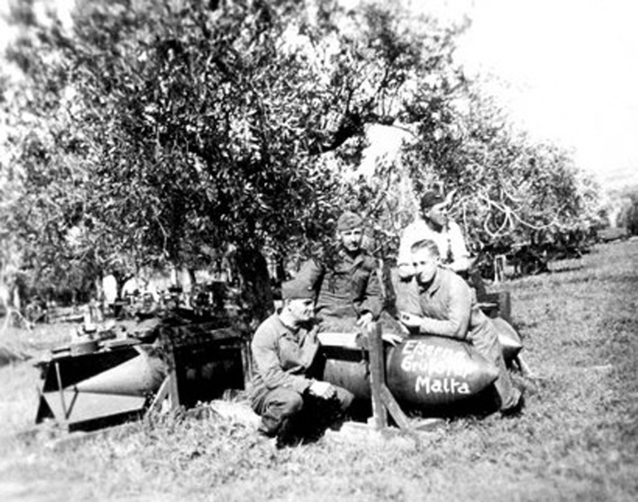

Left: Luftwaffe ground crew with bombs marked ‘Iron Greetings for Malta’.

UXBs DEALT WITH BY RE BD SECTIONS. MALTA 1940-1944

*Dec 1940 only
AP: Anti-personnel
E: estimated figures from Weekly BD Reports
L: Large number
Q: Quarter
S: Several

A: Lt Ashall B: Lt Blackwell C: Lt Carroll Lv: Lt Lavington T: Lt Talbot W: Lt Whitworth
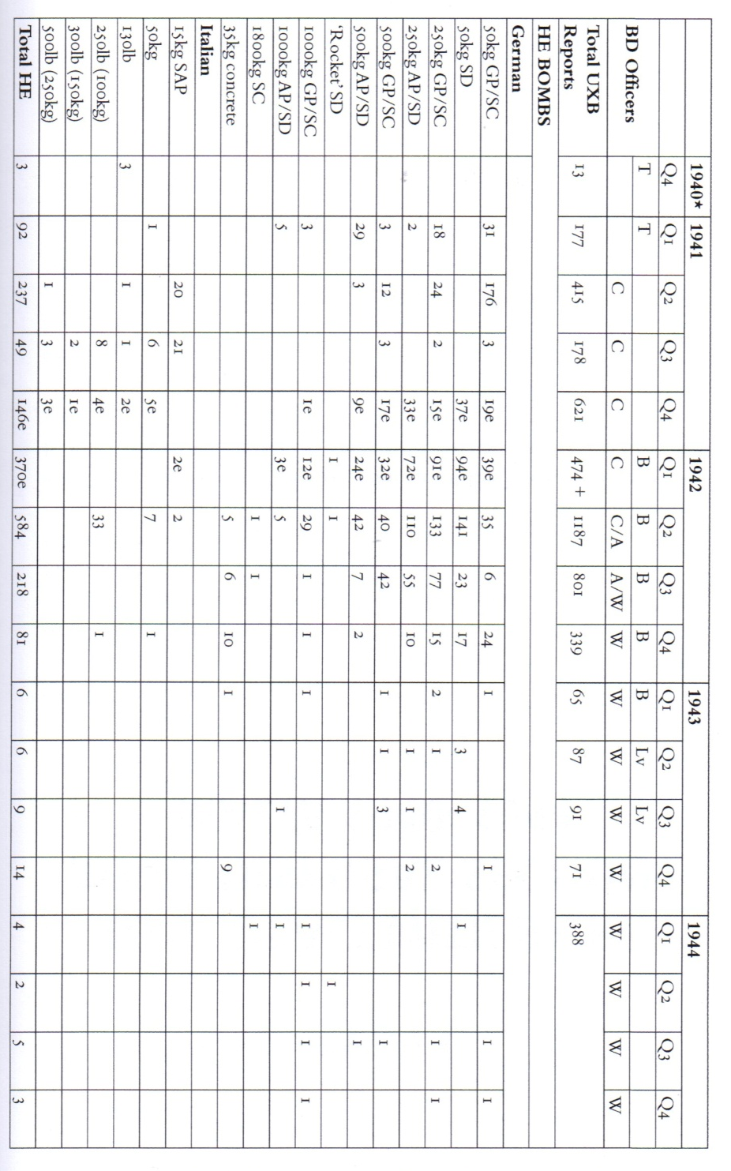

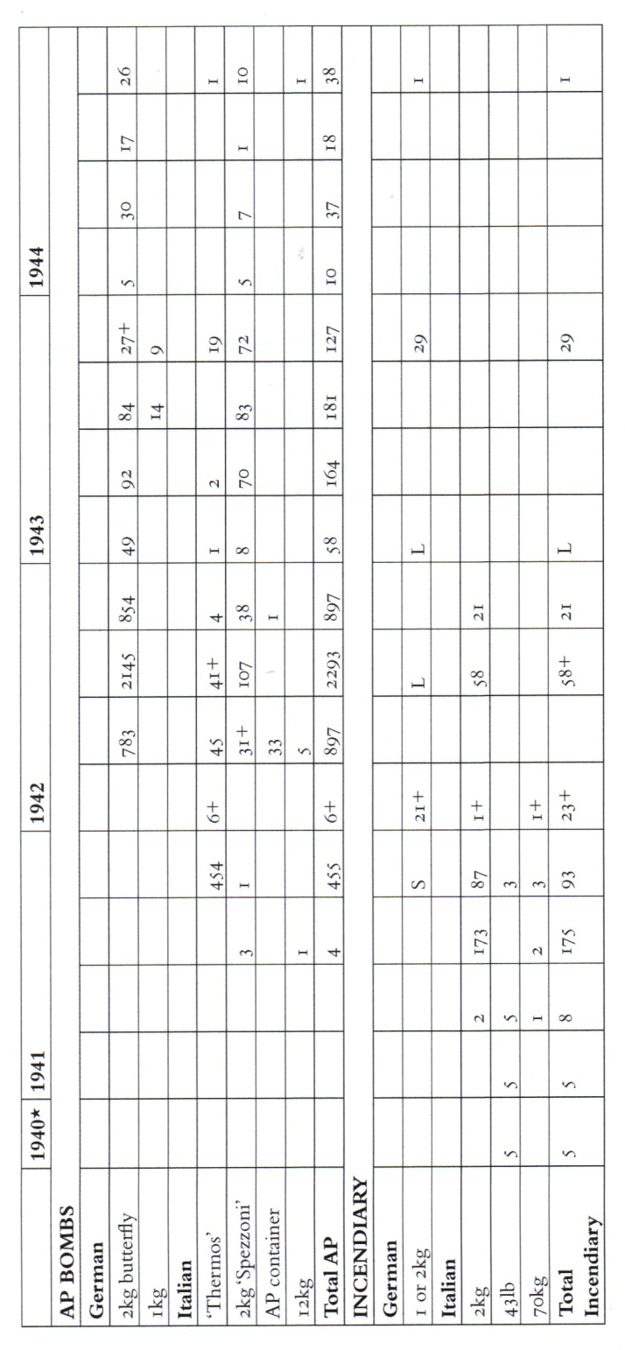

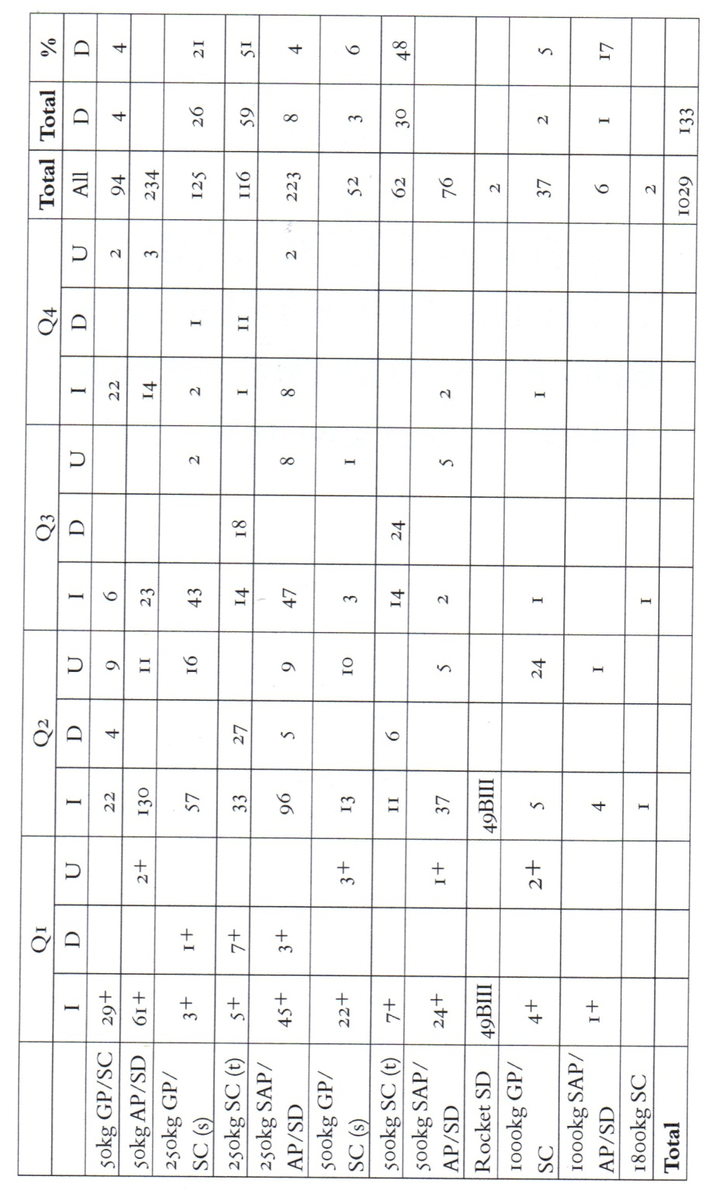
GERMAN FUZES IN HE BOMBS ENCOUNTERED BY RE BOMB DISPOSAL SECTIONS IN MALTA, 1942

There was no recorded use of a Delayed Action (DA) fuze before Jan 1942.
+ Total incomplete due to no Weekly Bomb Disposal Reports were produced between 21 Feb and 27 Mar 1942.
I: impact fuzes: 93% were Series 5, the remainder were Series 28 or 38.
D: delayed action
U: unidentified
SAP (Semi Armour Piercing)
SC: (spreng cylindrisch/General Purpose)
SD: (spreng dickenwand/Armour Piercing)
s: single fuze pocket
t: twin fuze pocket

BATTLEFIELD STUDY
LOCATIONS

Valetta:
Opera House
War Rooms
Saluting Battery
National War Museum
Mosta:
Rotunda
AFM EOD
Pieta CWGC cemetery

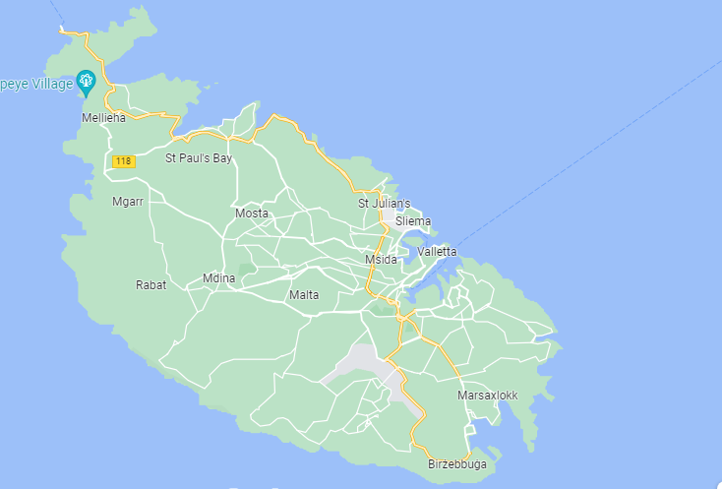
Capuccini Naval Cemetery, Kalkara
Malta at War Museum, Bormla
Fort Rinella

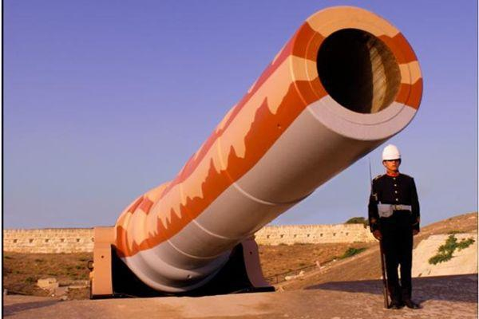

Left: 100 ton gun,
Fort Rinella

Can you find the ‘Promotion Hook’/ ‘Nelson’s Hook’ on St John’s Street, near St John’s Co-Cathedral?
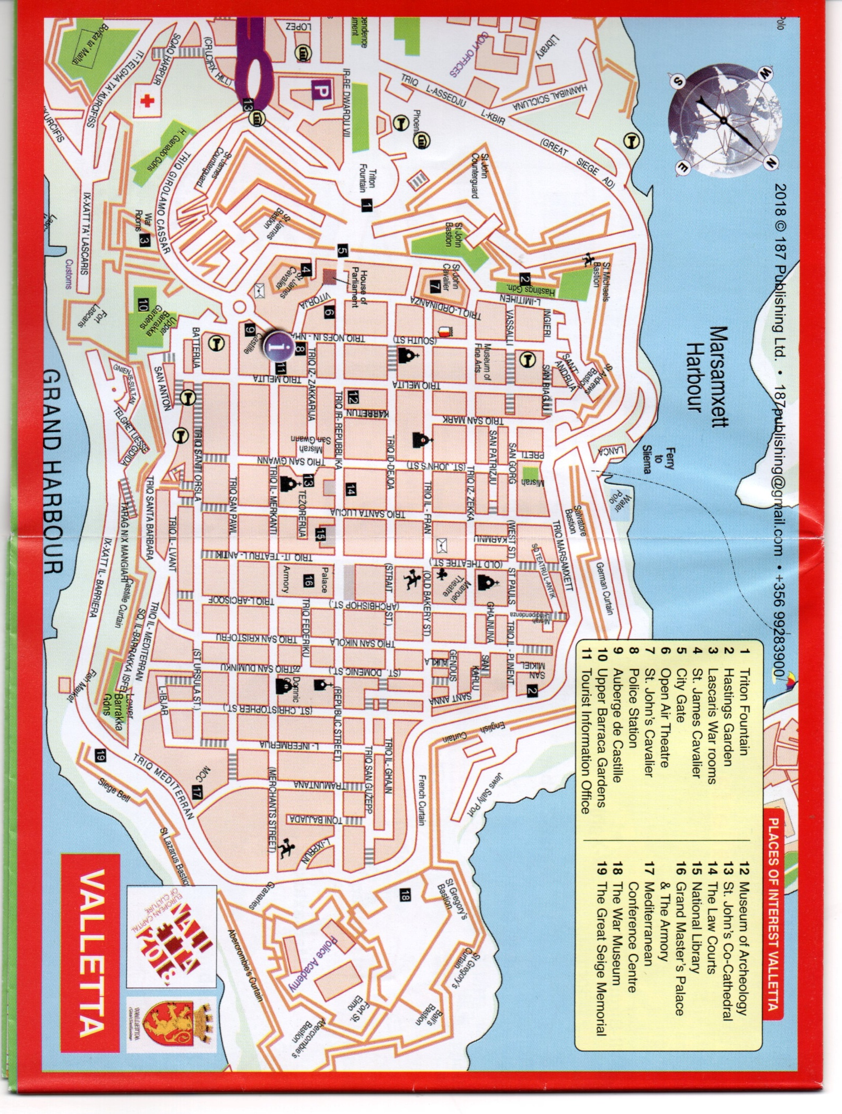
Royal Engineers personnel employed in Bomb Disposal work on Malta 1940-1944.

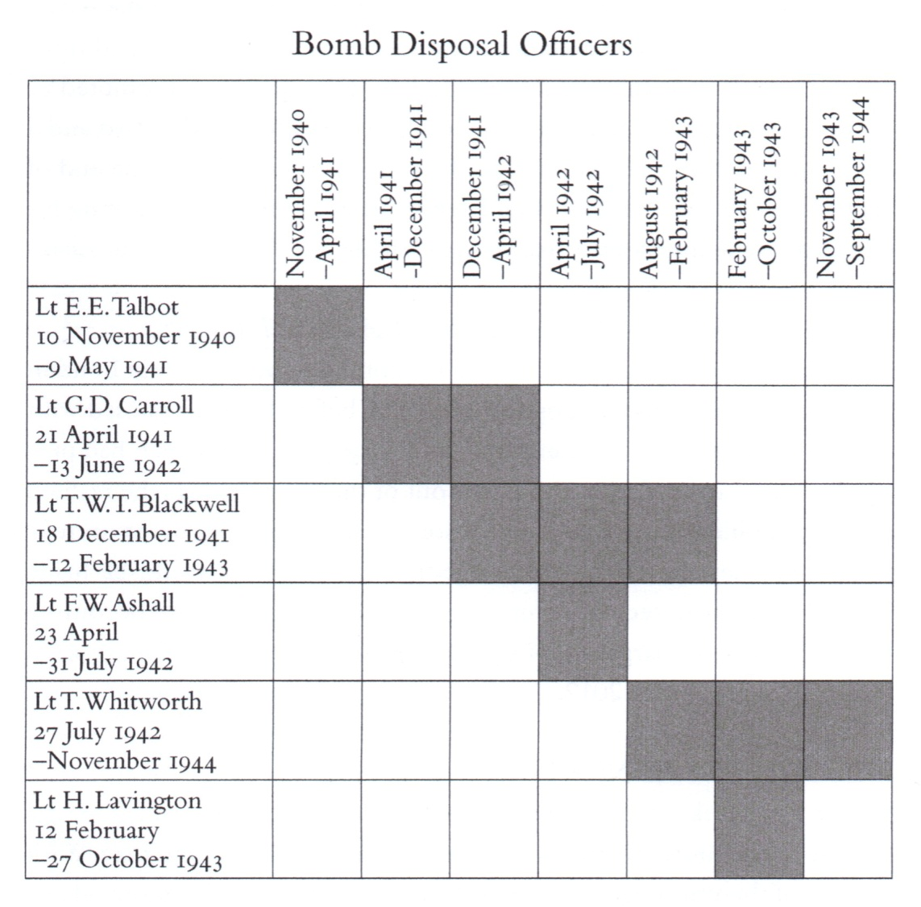

Members of 24 Fortress Coy RE, believed to have served in Nos. 127 and 128 Bomb Disposal Sections during this period.

Sgt | LSgt | Cpl | LCpl | Sprs
J. Holland | G.H. King | C.A. Brewer | R. Hilliar | J. Birchenall | L. Miller
T. Piggott | J.H. Lockett | R.R. Cushen | G. Jackson | G. Codling | ? Rattenbury
 | R.C. Parker |  | C.T. Meager | R. Garvin | H.J. Reeves
 |  |  | C.E. Reeves | T. Hammond | W.D. Scott
 |  |  |  | ? Lockyer | R.H. Walter
 |  |  |  | D. MacDonald | H. Turner
 |  |  |  | D. McCarthy | R.H. Walter

Further Reading:
Galea, F.R. Mines over Malta: Wartime Exploits of Commander Edward D. Woolley GM & Bar RNVR (Wise Owl, Malta, n.d).
Hudson, S.A.M. UXB Malta: Royal Engineers Bomb Disposal 1940-1944 (Cheltenham, The History Pres, 2012).
Noppen, R.K. Malta 1940-1942: The Axis’ Air Battle for Mediterranean supremacy, (Oxford, Osprey, 2018).
Rogers, A. The Battle of Malta: June 1940-November 1942 (Oxford, Osprey, 2022).
Williams. P.R. Malta: Island Under Siege (Barnsely, Pen & Sword, 2009).
Websites:
https://www.bombdisposalclub.org.uk/bomb-disposal-history/
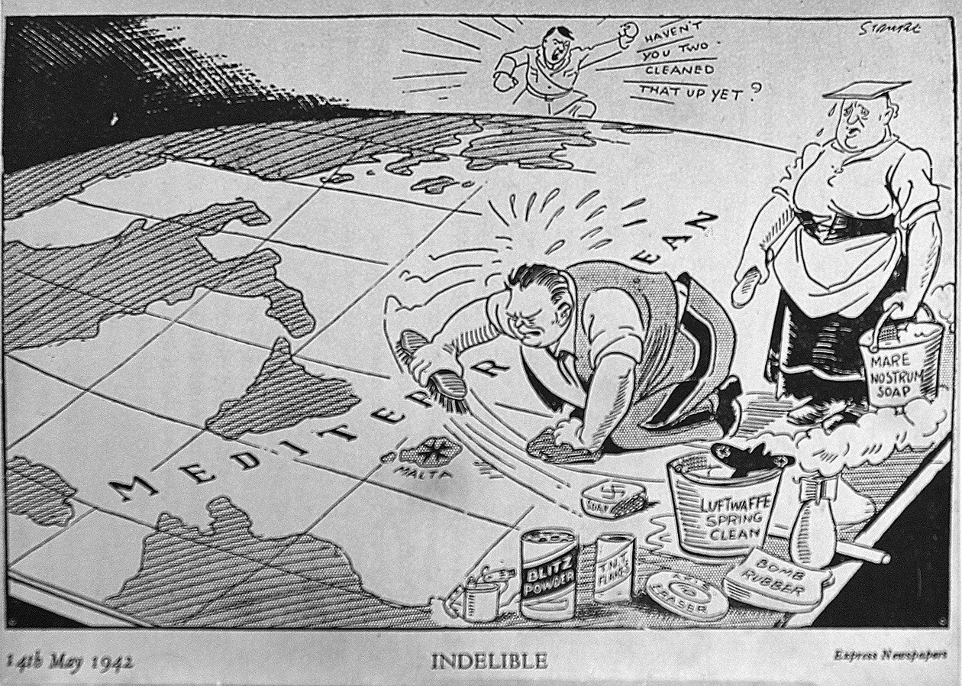
https://battlefrontmalta.com/royal-engineers-bomb-disposal-malta/

Prayer for EOD & Search:
Let us Remember before God
And commend to his sure memory
Those who have died in the process of Explosive Ordnance Disposal and Search
Those whom we knew and whose memory we treasure
And all who have lived and died in the service of humanity
Rev Andrew Jones, Norfolk.
Used at the Mundesley Bomb Disposal Memorial Service.

The Exhortation:
They shall grow not old as we that are left grow old
Age shall not weary them, nor the years condemn
At the going down of the sun
and in the morning
We Will Remember them
ALL: We Will Remember Them
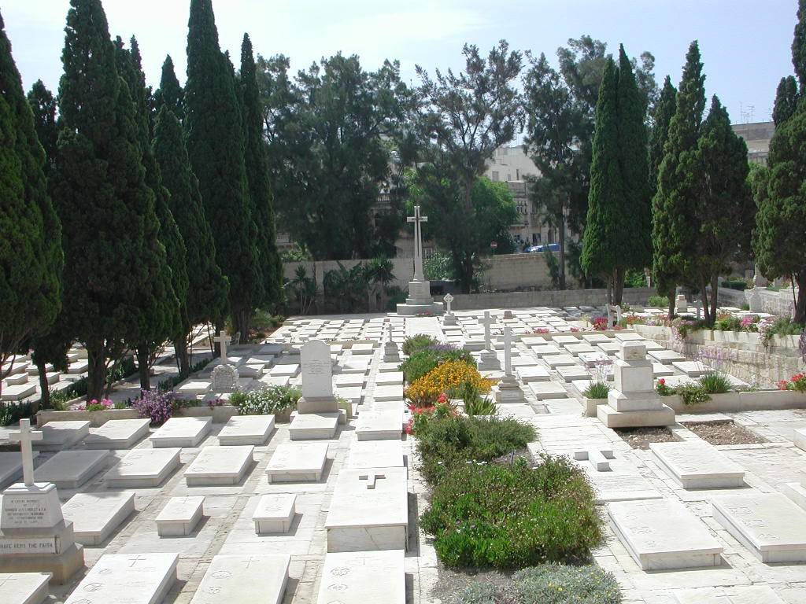

Pieta CWGC cemetery
Under the bastions there were arches where they created some storehouses.
One of the bombs that came down landed in the rubble on the top of the arch. It was stuck there. As the officer, I had to deal with it on my own. So I crawled across the arch with my trowel, like an archaeologist. I was scraping away gently to find the fuze about half way up the bomb.

Then suddenly the bomb fell, tight in front of my eyes...I died!
It hit the ground...and I died –
And it bounced...and I died –
And it rolled...and I died –
But I didn’t die.

That was the feeling when that happened in front of you.

Lt Carroll RE on dealing with a 250kg bomb at Lintorn Barracks, Malta 01 Apr 1942.

